Race condition
To understand race condition we first need to understand the basic structure of a program . how process executes and how the architecture of process execution works for that we need to cover the basics of the entire process architecture.
What is process ?
A process is a program that is currently being executed by the operating system. When you open an application such as Chrome, VS Code, Spotify, or a Java program, the operating system creates a process for it. A process gets its own memory space and resources such as code, data, heap, stack, and operating-system resources.
For example, suppose you write:
public class Main {
public static void main(String[] args) {
System.out.println("Hello");
}
}
When you run this Java program, the operating system/JVM creates an execution environment for the program. That running program is a process.
Think of a process as a house. The house has its own resources—rooms, electricity, furniture, etc.
Now the question arises if we already had processes to manage assigned task then why we needed threads ?
Processes were already used to execute and manage tasks, but creating a separate process for every task was expensive and inefficient. Each process has its own memory space and resources, so creating multiple processes requires more memory, takes more time, and communication between processes is comparatively difficult.
To solve this problem, threads were introduced as lightweight units of execution within a process. Multiple threads can exist inside a single process and share the same memory and resources, while each thread can perform a different task concurrently. This makes task execution faster and more efficient and reduces the overhead of creating multiple processes.
For example, a web browser may need to download a file, play a video, and respond to user input at the same time. Instead of creating a separate process for each task, the browser can use multiple threads within the same process.
Processes provide independent execution and isolation, while threads provide lightweight and efficient concurrent execution within the same process. This is why threads were needed.

What are threads and why do we need threads in process execution?
Threads can be defined as the smallest unit of execution . threads are the smallest unit of execution in a process and a process can have multiple threads.
For example:
Thread 1 | Thread 2 | Thread 3
Download | Music | Input
PROCESS
In the executing environment the process acts as a container and holds the common resources which are needed by thread for there execution these are code section , heap memory , gloabal/static variable , process resources , address space and there are some resources which are individual for each thread like stack program counter , cpu register , thread id , thread state , thread local storage .
The need for threads comes from the need to perform multiple activities within the same program efficiently. Imagine a program that has to download a large file.
Without multithreading
Download file -> Wait 10 seconds -> Download complete -> Process user input
During the download, the program may spend a lot of time waiting for the network. That is inefficient. Suppose the process has 2 threads then , While Thread 1 is waiting for the network, Thread 2 can continue handling user interaction. Therefore, threads help us keep the program responsive and make better use of available CPU time.
Now if everything was working fine with threads in a process then why we need multithreading ?
A single thread inside a process can execute only one sequence of instructions at a time. Although threads solved the problem of expensive process creation, using only one thread still meant that tasks had to be performed one after another.
For example, suppose a program needs to:
Task 1 → Download a file
Task 2 → Process data
Task 3 → Handle user input
If Task 1 takes a long time, the other tasks have to wait.
To solve this, we use multithreading, where a single process contains multiple threads that can execute different tasks concurrently. Now, while one thread is waiting for I/O or performing a task, another thread can continue working. On a multi-core CPU, multiple threads may also execute in parallel on different CPU cores.
Therefore, multithreading was needed to improve responsiveness, resource utilization, and overall performance by allowing multiple tasks to make progress concurrently within the same process.
Above we discussed about multithreading where multiple threads execue together but the question arise how multiple threads execute together ?
When we talk about multiple threads executing together, two important concepts are concurrency and parallelism. They are related, but they are not the same thing.
Concurrency means that multiple tasks are in progress during the same period of time, but they do not necessarily execute at the exact same moment. The CPU can switch between different threads very quickly, giving the impression that they are running simultaneously. Concurrency can happen even on a single-core CPU. In concurrency The CPU rapidly switches between threads, so both tasks make progress.
Whereas parallelism on the other side means that multiple tasks are actually executing at the same time, usually on different CPU cores.
So, multithreading can provide concurrency, and on a multi-core processor, multiple threads can also execute in parallel.
BUT THREADS ARE NOT PERFECT
And that’s where race conditons and shared variable problem comes to the role.
Now the question arises that What is a race condition, and what is the core concept that makes a race condition possible?
A thread is an independent path of execution inside a process. Multiple threads are useful because they allow different tasks to make progress concurrently and, on multicore CPUs, potentially execute in parallel.
But there is an important consequence: threads belonging to the same process share the process's memory/resources.
For example:
class Counter {
int count = 0;
}
Suppose we create two threads:
Now in this situation both the threads can access the counter object. But when multiple threads can modify the same data, we get what is called shared mutable state.
And shared mutable state is the actual core concept which is responsible for the race condition
What is shared mutable state and why does it occur ?
Shared mutable state is data that:
- Is shared → multiple threads can access the same data.
- Is mutable → that data can be changed.
- Is accessed concurrently → multiple threads may access/change it at overlapping times.
Shared mutable state occurs in multithreaded programs because multiple threads belonging to the same process share the same memory and can access the same objects and variables. When a variable or object is stored in shared memory and its value is allowed to change, it becomes both shared and mutable. For example, if a Counter object contains int count = 0, and two threads have access to the same Counter object, both threads can read and modify count. This sharing happens because threads are designed to work within the same process and therefore share resources such as heap memory, while each thread still has its own execution path and stack. Shared mutable state becomes a problem when multiple threads modify the same data concurrently, because their operations may overlap or be interleaved. For example, if both threads execute count++, they may read the same old value before either thread writes its updated value, causing one update to be lost. Therefore, shared mutable state occurs naturally because threads share memory, and it becomes dangerous when that shared data can be modified concurrently without proper synchronization.
What is a Race Condition?
A race condition is a situation in a concurrent or multithreaded program where two or more threads access and operate on the same shared data at the same time, and the final result depends on the order in which those operations happen. Since the threads can execute in different orders, the program may produce an incorrect or unexpected result even though the code appears logically correct when executed by a single thread.
Why does a Race Condition occur?
A race condition occurs when multiple threads concurrently access shared mutable data and at least one of them modifies it without proper synchronization. The threads are essentially "racing" to read and update the same data. If their operations overlap in an unsafe way, one thread can overwrite another thread's update, resulting in an incorrect final value.
Why does a Race Condition happen in multithreading?
The main reason is shared mutable state. When multiple threads share the same variable and are allowed to modify it concurrently, their operations can interfere with each other. The problem becomes more serious when an operation involves multiple steps, such as reading a value, modifying it, and then writing it back. Without synchronization, another thread can access the same value between these steps, causing inconsistent results.
For example, if four threads are simultaneously modifying a shared counter, each thread expects its increment to be reflected in the final result. However, because their read and write operations can overlap, some updates may be overwritten. This is what creates the race condition.

Practical Demonstration of Race Condition :
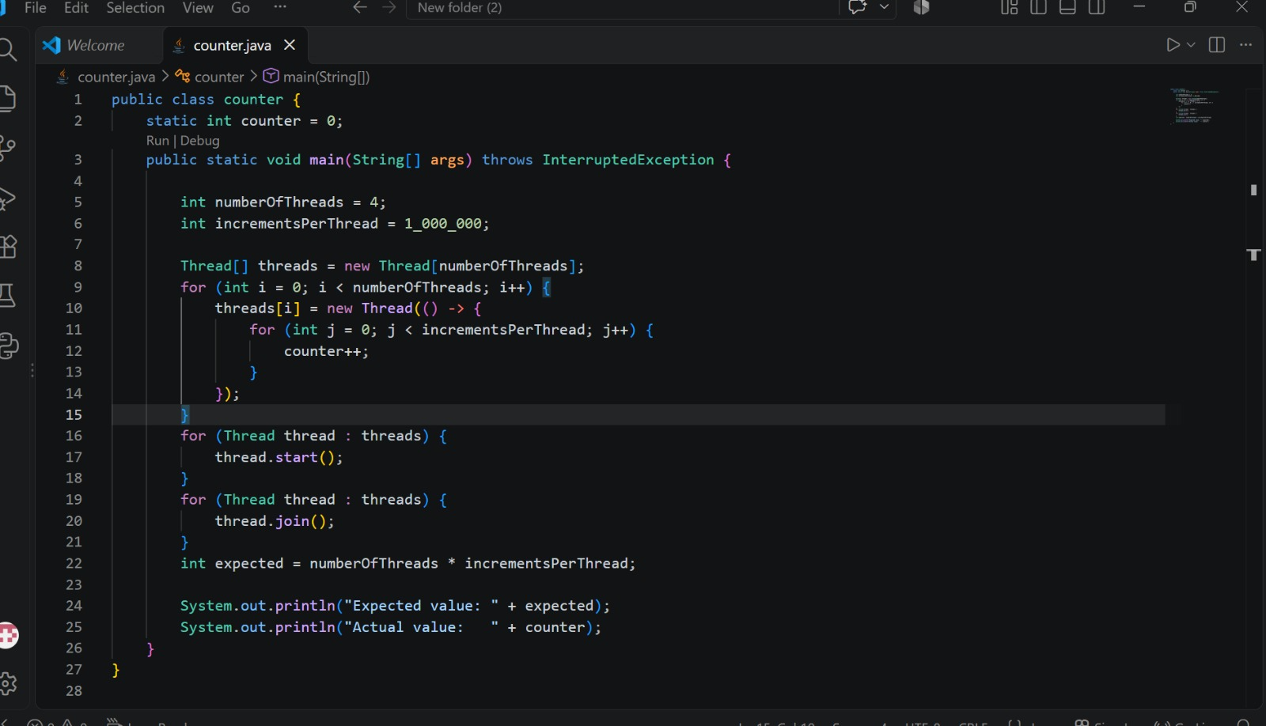
Output of the code :
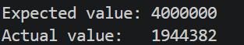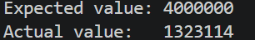
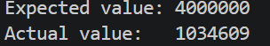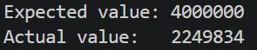
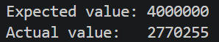

Run | Expected Value | Actual Value
1 | 4,000,000 | 1944382
2 | 4,000,000 | 1323114
3 | 4,000,000 | 1034609
4 | 4,000,000 | 2249834
5 | 4,000,000 | 2770255

Practical Demonstration of Race Condition
The following Java program demonstrates a race condition by creating four threads that concurrently modify the same shared variable. Each thread increments the shared counter one million times.
Code Explanation
- Shared Mutable Variable
static int counter = 0;
The counter variable is the shared mutable state in this program. It is shared because all four threads access the same variable, and it is mutable because its value can be changed during program execution. Since multiple threads modify this variable concurrently, it becomes the shared resource involved in the race condition.
- Number of Threads
int numberOfThreads = 4;
This specifies that the program will use four threads. All four threads perform the same operation on the same shared counter variable.
- Number of Increments
int incrementsPerThread = 1_000_000;
This specifies that each thread will increment the counter one million times. Since there are four threads, the expected total number of increments is:
4 × 1,000,000 = 4,000,000
Therefore, the expected final value of the counter is 4,000,000.
- Creating the Threads
Thread[] threads = new Thread[numberOfThreads];
for (int i = 0; i < numberOfThreads; i++) {
threads[i] = new Thread(() -> {
A Thread array is created to store the four threads. The for loop creates four separate threads. Each thread receives the same task: increment the shared counter.
- Incrementing the Shared Counter
for (int j = 0; j < incrementsPerThread; j++) {
counter++;
}
This is the most important part of the experiment. Each thread executes counter++ one million times. Since all four threads modify the same shared variable concurrently, their operations can interfere with one another.
Although counter++ appears to be a single operation, it is conceptually a read-modify-write operation:
READ counter
↓
ADD 1
↓
WRITE the new value
For example, suppose the counter currently contains 100. Two threads may execute the operation as follows:
Thread 1 → READ 100
Thread 2 → READ 100
Thread 1 → Calculate 101
Thread 2 → Calculate 101
Thread 1 → WRITE 101
Thread 2 → WRITE 101
After two increments, the expected value should be 102, but the actual value becomes 101. One update has been lost. This is called a lost update and is a consequence of the race condition.
- Starting the Threads
for (Thread thread : threads) {
thread.start();
}
The start() method starts each thread and allows them to execute concurrently. The exact order in which the threads execute is not fixed. Their operations can be interleaved in different ways during different executions. This is known as nondeterministic interleaving.
- Waiting for All Threads to Finish
for (Thread thread : threads) {
thread.join();
}
The join() method makes the main thread wait until each worker thread has completed its execution. This ensures that the final value of counter is printed only after all four threads have finished their one million increments.
- Calculating the Expected Value
int expected = numberOfThreads * incrementsPerThread;
The expected value is calculated as:
4 × 1,000,000 = 4,000,000
This is the value we would expect if every increment were performed safely without any updates being lost.
- Displaying the Result
System.out.println("Expected value: " + expected);
System.out.println("Actual value: " + counter);
The program displays both the expected value and the actual value obtained after all four threads finish execution.
The expected value is always 4,000,000. The actual value is obtained from the program's execution and may be lower because some updates can be lost due to concurrent access to the shared variable.
What Does the Experiment Demonstrate?
The experiment demonstrates that multiple threads can concurrently access and modify the same shared mutable variable. Because counter++ is not an atomic operation, its read, modify, and write steps can overlap between threads. This can cause one thread's update to overwrite another thread's update, resulting in lost updates.
Therefore, when the actual result differs from the expected result, it provides practical evidence of a race condition.
Execution Flow
Four Threads
↓
Same Shared Counter
↓
1,000,000 Increments per Thread
↓
counter++ (Read → Modify → Write)
↓
Concurrent Interleaving
↓
Lost Updates
↓
Actual Result May Differ from Expected Result
↓
Race Condition
now we understood what is race condition but how do we prevent the race condition ?
After observing the race condition in the previous experiment, the next question is: how can we prevent multiple threads from incorrectly modifying the same shared data at the same time?
The solution is synchronization. Synchronization is a mechanism used in concurrent programming to control access to shared resources when multiple threads are executing concurrently. It ensures that operations that must be performed safely are protected from interference by other threads.
In Java, one of the simplest ways to achieve synchronization is by using the synchronized keyword.
Why Do We Need Synchronization?
Synchronization is needed when multiple threads access and modify the same shared mutable data concurrently. Without synchronization, threads may interleave their operations in an unsafe manner, causing race conditions, lost updates, and inconsistent results.
In our previous example, four threads were simultaneously executing counter++. Since counter++ is a read-modify-write operation, two or more threads could read the same old value and later overwrite each other's updates.
Synchronization provides a way to control this access so that only one thread at a time can execute the protected operation.
How synchronization works ?
Synchronization works mainly through three related concepts: critical section, lock, and mutual exclusion.
A critical section is the part of the program where shared data is accessed or modified. In our example, counter++ is the critical section because multiple threads are modifying the same shared counter variable.
A lock is used to control access to this critical section. When a thread enters a synchronized section, it acquires the lock. Other threads that try to enter the same synchronized section must wait until the lock is released.
This provides mutual exclusion, which means that only one thread can execute the critical section at a time. Therefore, while one thread is modifying the shared counter, no other thread can modify it simultaneously.
So, the relationship is:
Critical Section | The code that accesses shared data
↓
Lock | Controls access to the critical section
↓
Mutual Exclusion | Ensures only one thread enters it at a time
Together, these mechanisms allow synchronization to prevent race conditions and lost updates.
Practical implementation of the synchrinization:
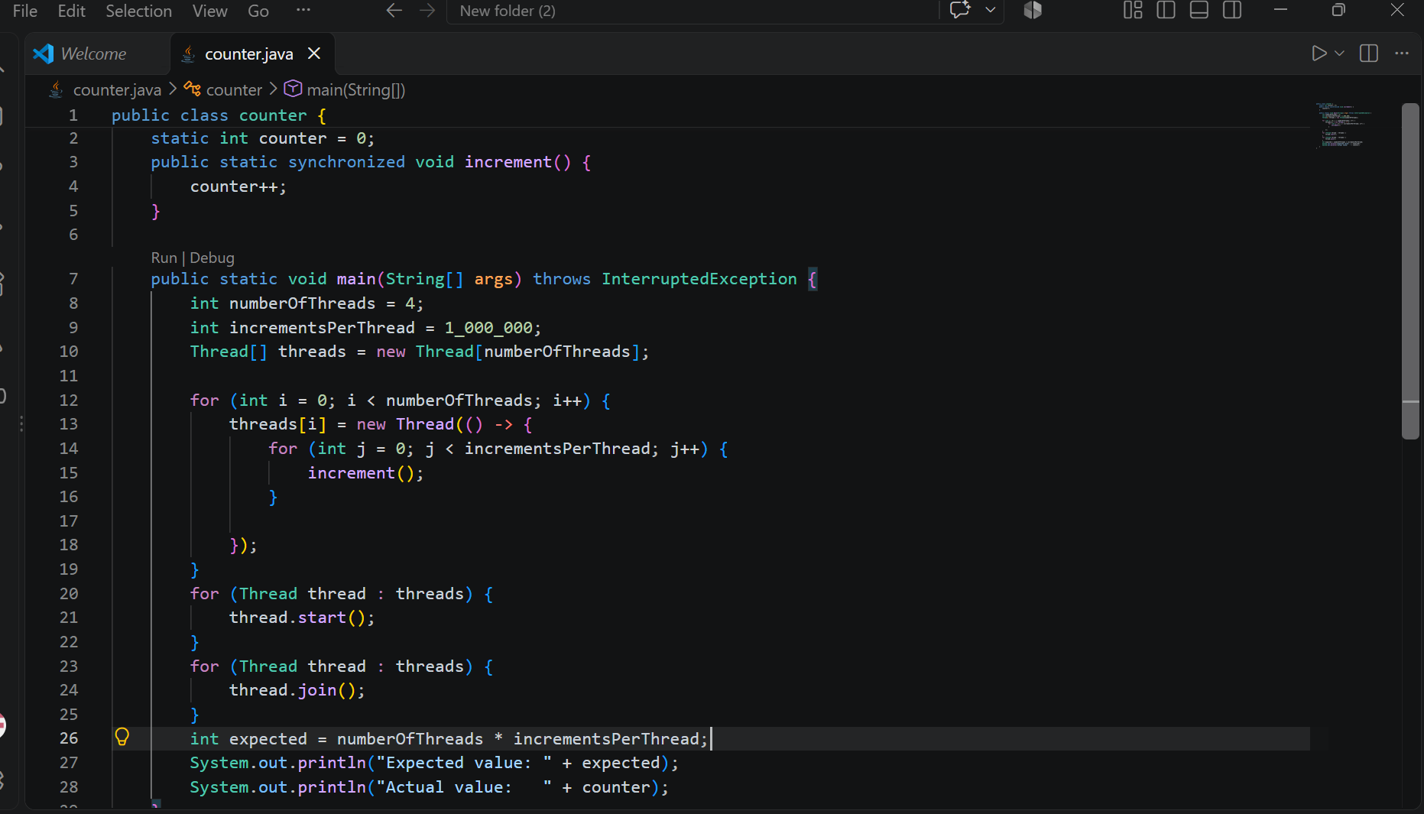

Output of the practical implementation:
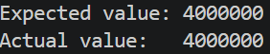

Run | Expected Value | Actual Value
1 | 4,000,000 | 4,000,000
2 | 4,000,000 | 4,000,000
3 | 4,000,000 | 4,000,000
4 | 4,000,000 | 4,000,000
5 | 4,000,000 | 4,000,000

Code elaboration of practical implementation:
- Shared Counter
static int counter = 0;
The counter is a shared mutable variable because all four threads access and modify the same variable.
- Synchronized Method
public static synchronized void increment() {
counter++;
}
The synchronized keyword protects the increment() method. When one thread enters this method, it acquires the lock. Other threads trying to enter the same method must wait until the lock is released.
Therefore, only one thread can execute counter++ at a time. This provides mutual exclusion and protects the critical section.
- Creating Threads
int numberOfThreads = 4;
int incrementsPerThread = 1_000_000;
The program creates 4 threads, and each thread performs 1,000,000 increments.
Expected result = 4 × 1,000,000 = 4,000,000.
- Calling the Increment Method
Each thread repeatedly calls:
increment();
Since increment() is synchronized, threads cannot execute counter++ simultaneously. One thread executes it while the others wait for the lock.
- Starting Threads
thread.start();
The start() method starts each thread. All threads can execute concurrently, but access to the synchronized method is controlled by the lock.
- Lock and Mutual Exclusion
When a thread enters the synchronized method, it acquires the lock.
Thread 1
↓
Acquire Lock
↓
counter++
↓
Release Lock
Other threads wait until the lock becomes available.
This ensures mutual exclusion, meaning only one thread can execute the critical section at a time.
- Critical Section
The critical section is:
counter++;
It is the part of the program that modifies the shared variable. Synchronization protects this operation from being executed by multiple threads at the same time.
- join()
thread.join();
The join() method makes the main thread wait until all worker threads finish. This ensures that the final counter value is printed only after all increments are completed.
- Expected vs Actual Result
The expected value is:
4 × 1,000,000 = 4,000,000
The synchronized program should produce:
Expected value: 4000000
Actual value: 4000000
- How Synchronization Fixes the Race Condition
In the race-condition version, multiple threads could execute counter++ at the same time, causing lost updates.
In the synchronized version, the increment operation is protected by a lock. Only one thread can execute the critical section at a time.
Therefore:
Critical Section | counter++
↓
Lock | Controls access to the critical section
↓
Mutual Exclusion | Only one thread enters at a time
↓
Synchronization | Provides safe access to shared data
As a result, lost updates are prevented and the actual result matches the expected result.
References :
[1] Oracle, “Synchronization,” The Java Tutorials, Oracle. Available: https://docs.oracle.com/javase/tutorial/essential/concurrency/sync.html
[2] Oracle, “Threads and Locks,” The Java Language Specification, Chapter 17. Available: https://docs.oracle.com/en/java/javase/26/docs/specs/jls/jls-17.html
[3] MIT OpenCourseWare, “Thread Safety,” 6.005 Software Construction, Massachusetts Institute of Technology. Available: https://ocw.mit.edu/ans7870/6/6.005/s16/classes/20-thread-safety/

